**DBMS LAB ASSIGNMENT 5**

**K.V.L.AMRUTHA**

**19BCS048**

**1. Illustrate logical ANY, ALL and LIKE operator- the queries should be relevant to your respective databases 3 queries for each operator. One query explaining the**

**difference between ANY and ALL**

use T10_TRAVEL

select * from T10_bookingdetails

where customer_id >ANY(select customer_id from T10_bookingdetails

where booking_title= 'single')

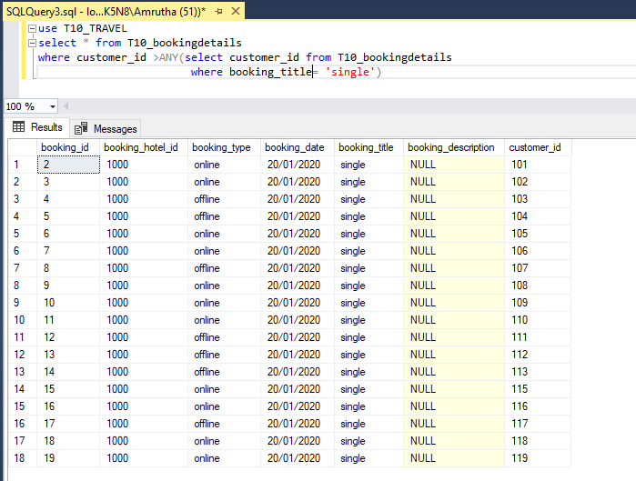

use T10_TRAVEL

select * from T10_customerdetails

where customer_id > ANY (select customer_id from T10_customerdetails

where age= 20);

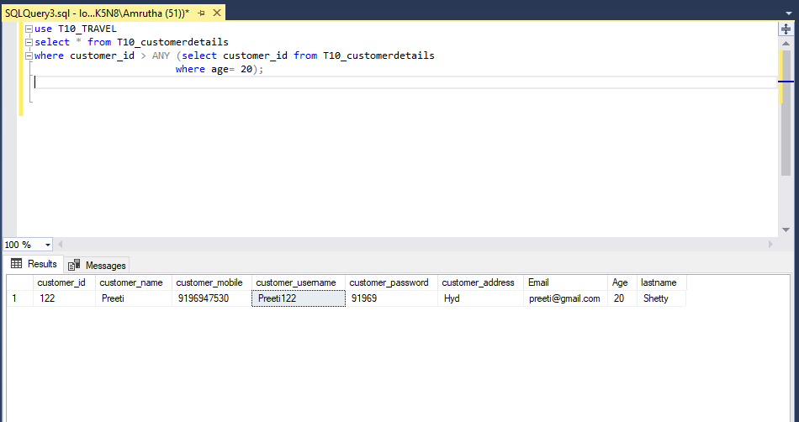

use T10_TRAVEL

select * from T10_customerdetails

where customer_id < ANY (select customer_id from T10_customerdetails

where age= 20);

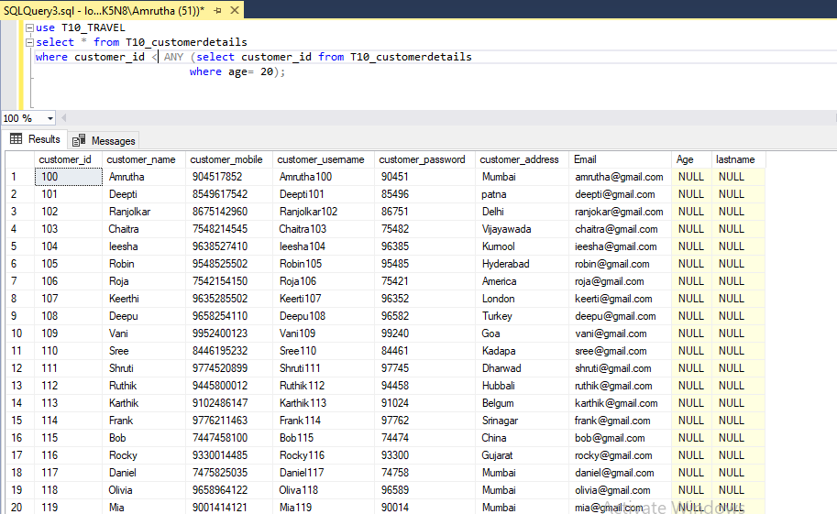

use T10_TRAVEL

select * from T10_customerdetails

where customer_id < ALL (select customer_id from T10_customerdetails

where age= 20); 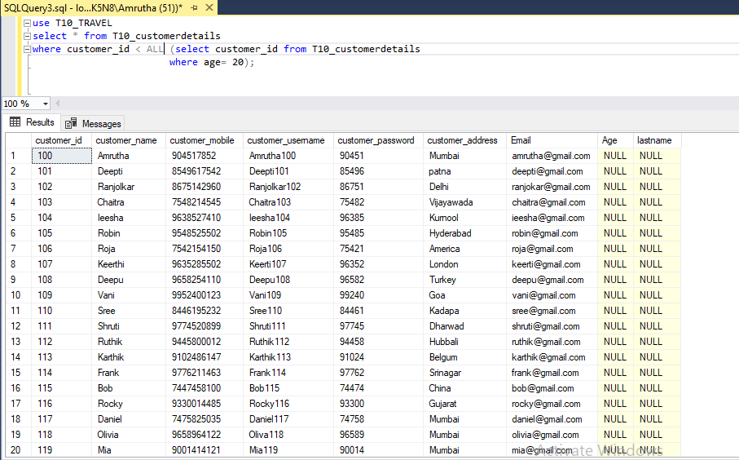

use T10_TRAVEL

select * from T10_customerdetails

where customer_id > ALL (select customer_id from T10_customerdetails

where customer_address= 'Mumbai');

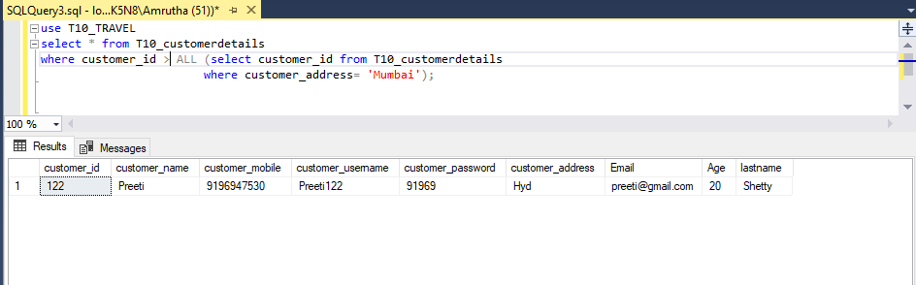

use T10_TRAVEL

select * from T10_customerdetails

where customer_id < ALL (select customer_id from T10_customerdetails

where customer_id>110);

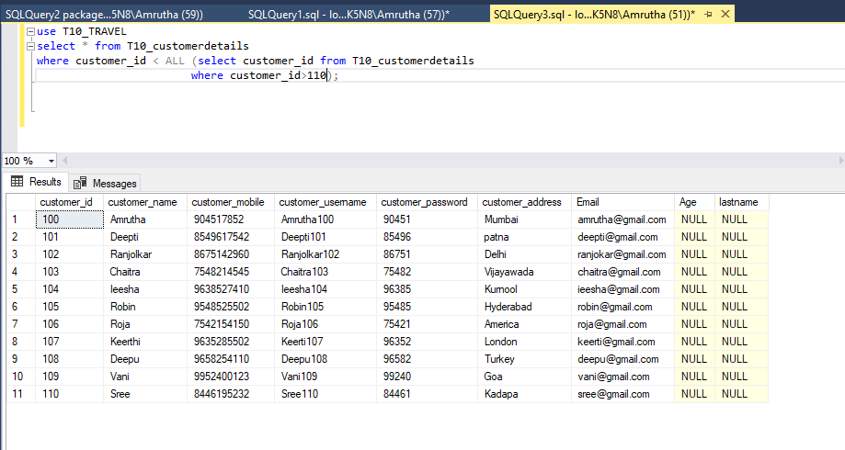

SELECT customer_name, customer_address FROM T10_customerdetails

WHERE customer_name LIKE '%a%'

SELECT customer_id, Email FROM T10_customerdetails

WHERE customer_name LIKE '%an%'

SELECT customer_name, customer_address FROM T10_customerdetails

WHERE customer_name LIKE '_a%'

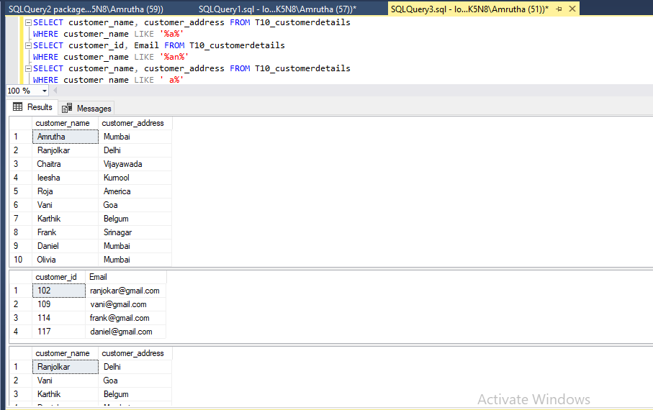

**2. One query for each Aggregate function.**

SELECT AVG(package_amount)

FROM T10_packagedetails;

SELECT COUNT(customer_mobile)

FROM T10_customerdetails;

SELECT MIN(customer_mobile)

FROM T10_customerdetails;

SELECT MAX(customer_mobile)

FROM T10_customerdetails;

SELECT SUM(package_total)

FROM T10_packagedetails;

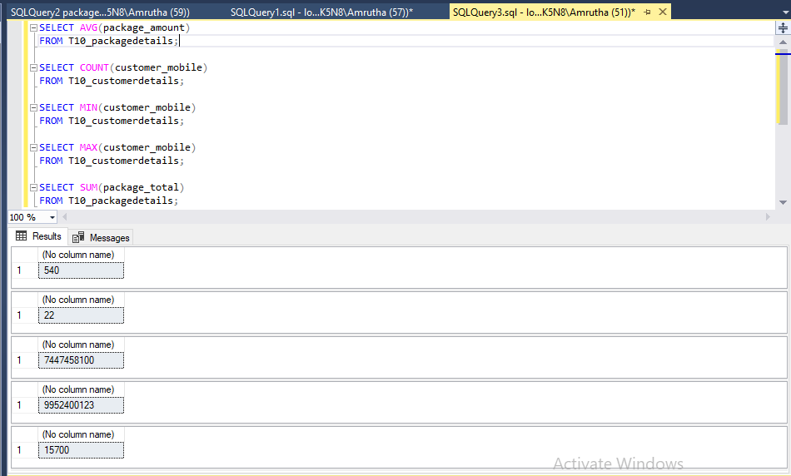

**3. Illustrate the usage of order by, group by and having clause (2 queries for each case)**

SELECT * FROM T10_customerdetails

ORDER BY customer_mobile ASC;

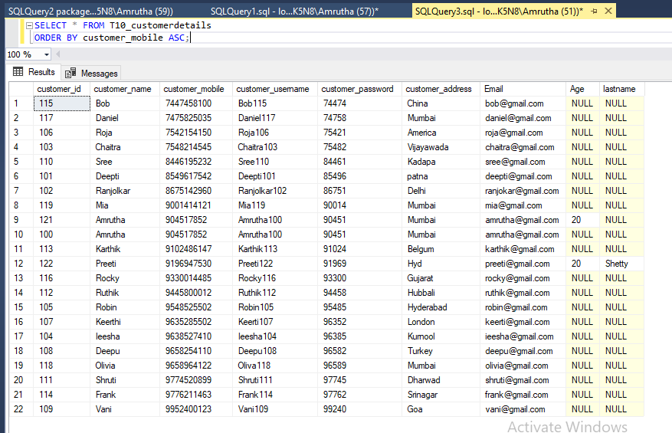

SELECT * FROM T10_customerdetails

ORDER BY customer_address DESC;

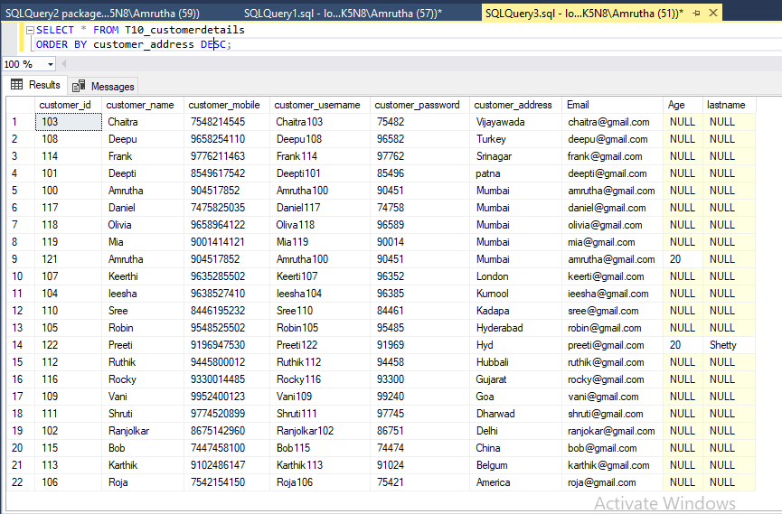

SELECT customer_address,COUNT(*)

FROM T10_customerdetails

GROUP BY customer_address ;

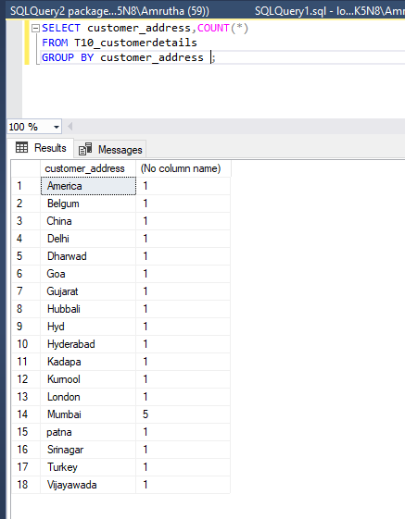

SELECT package_amount,COUNT(*)

FROM T10_packagedetails

GROUP BY package_amount;

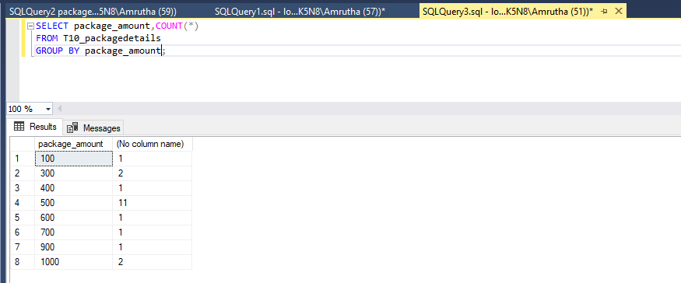

SELECT package_amount,COUNT(package_amount)

FROM T10_packagedetails

GROUP BY package_amount

HAVING COUNT(package_amount) > 5;

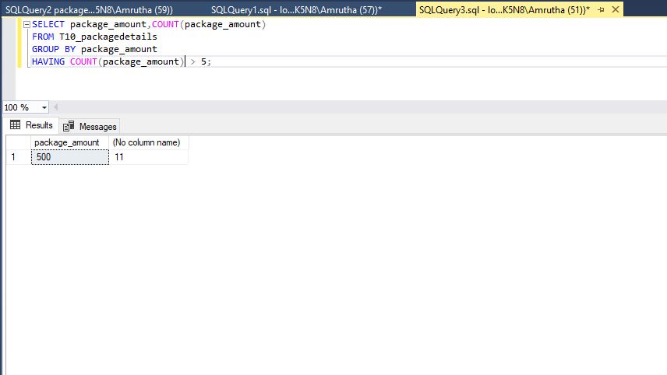

SELECT package_amount,COUNT(package_total)

FROM T10_packagedetails

GROUP BY package_amount

HAVING COUNT(package_total) > 1;

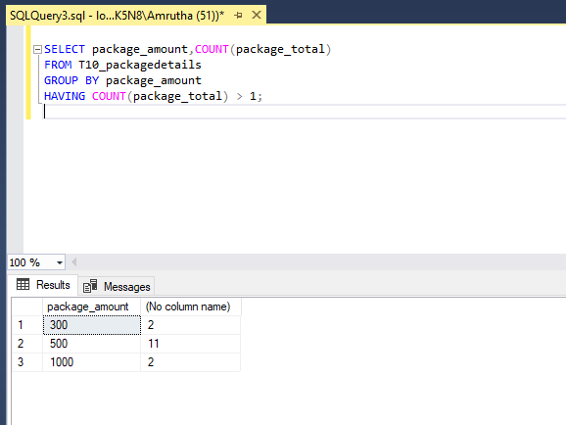

**4. Use Aggregate function with group by and having**

SELECT package_amount,COUNT(package_total),AVG(package_total)

FROM T10_packagedetails

GROUP BY package_amount

HAVING COUNT(package_total) > 1;

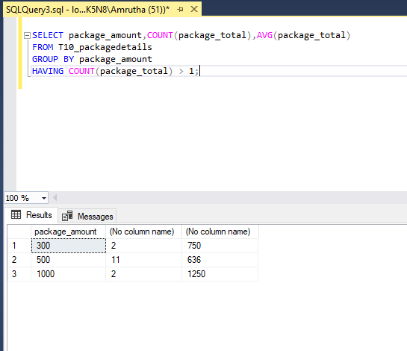

SELECT package_amount,COUNT(package_total)

FROM T10_packagedetails

GROUP BY package_amount

HAVING package_amount >400;

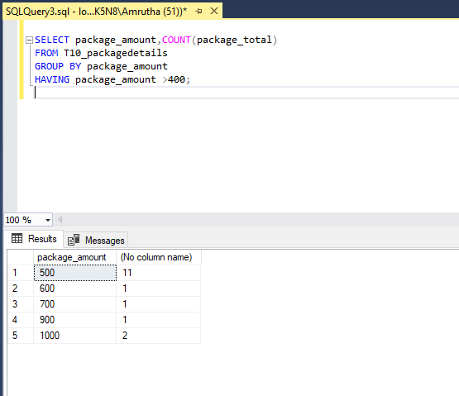

USE T10_TRAVEL

SELECT customer_address,MIN(customer_mobile)

FROM T10_customerdetails

GROUP BY customer_address

HAVING customer_address = 'Mumbai';

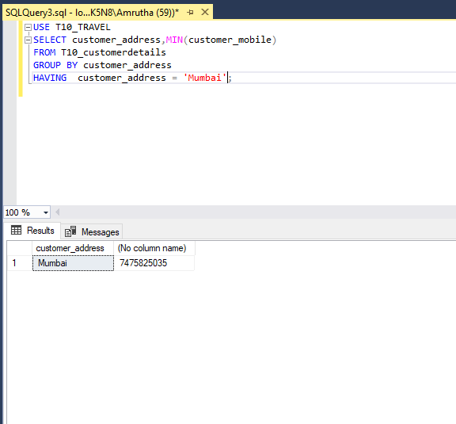

USE T10_TRAVEL

SELECT customer_address,MAX(customer_mobile)

FROM T10_customerdetails

GROUP BY customer_address

HAVING customer_address = 'Mumbai';

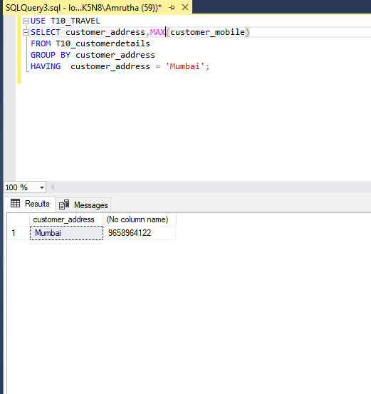

USE T10_TRAVEL

SELECT customer_address,SUM(customer_id)

FROM T10_customerdetails

GROUP BY customer_address

HAVING customer_address = 'Mumbai';

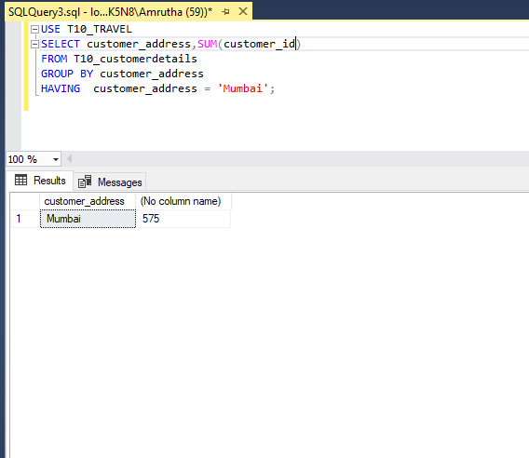

**5. Write at least 3 nested queries using order by, group by and having clause.**

SELECT package_amount,SUM(package_total)

FROM T10_packagedetails

WHERE customer_id = ANY

(

SELECT customer_id

FROM T10_bookingdetails

where customer_id = ANY

(

SELECT customer_id

FROM T10_packagedetails

Where package_amount>500

)

)

GROUP BY package_amount

HAVING package_amount <1500

ORDER BY package_amount ASC;

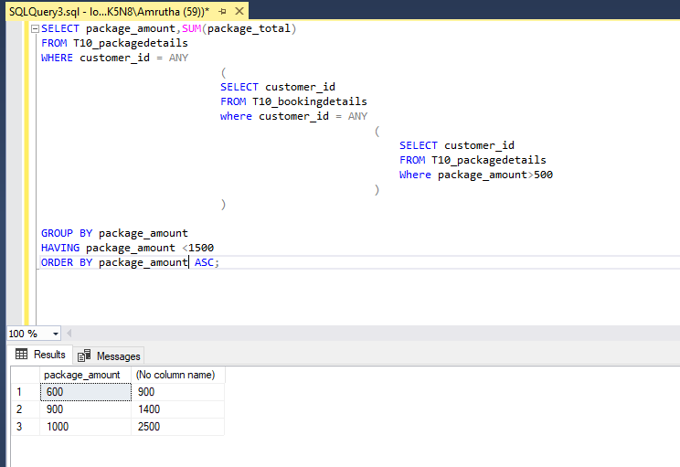

**6. Illustrate the Usage of Except, Exists, Not Exists, Union, Intersection**

USE T10_TRAVEL

SELECT customer_id

FROM T10_customerdetails

EXCEPT

SELECT customer_id

FROM T10_bookingdetails

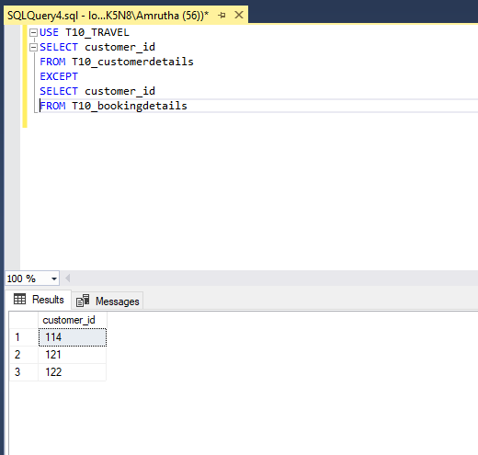

SELECT * FROM T10_customerdetails

WHERE EXISTS (

SELECT customer_id

FROM T10_bookingdetails

)

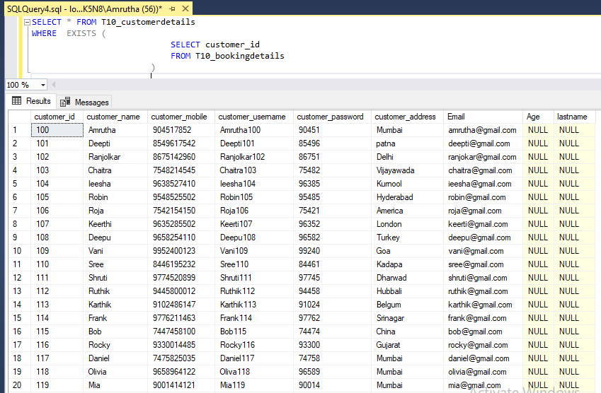

SELECT * FROM T10_customerdetails

WHERE NOT EXISTS (

SELECT customer_id

FROM T10_bookingdetails

)

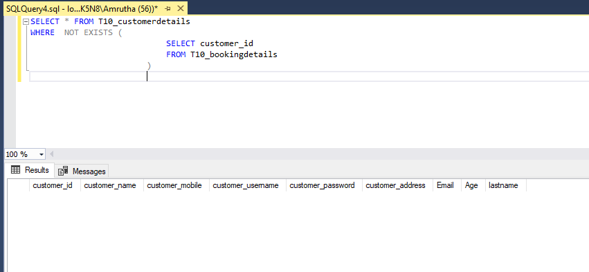

SELECT customer_id

FROM T10_packagedetails

UNION

SELECT customer_id

FROM T10_bookingdetails

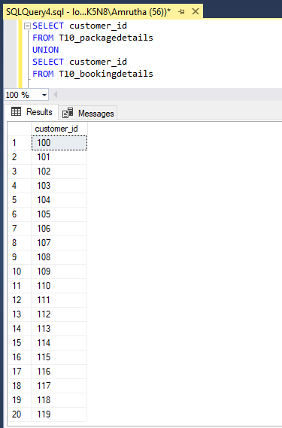

SELECT customer_id

FROM T10_packagedetails

INTERSECT

SELECT customer_id

FROM T10_bookingdetails

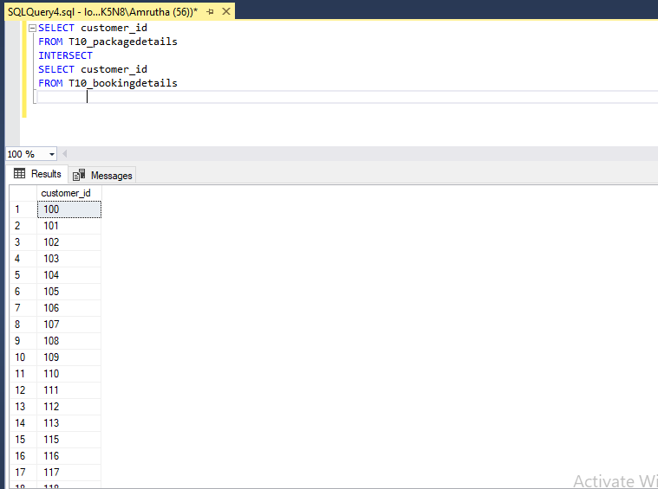

**7. INNER JOIN, LEFT OUTER JOIN, RIGHT OUTER JOIN- 3 queries for each instance**

SELECT *

FROM T10_customerdetails AS customer

INNER JOIN

T10_bookingdetails AS booking

on customer.customer_id= booking.customer_id

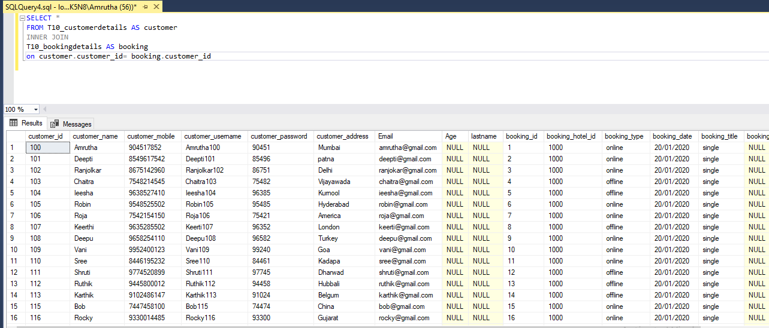

SELECT *

FROM T10_bookingdetails AS customer

INNER JOIN

T10_packagedetails AS booking

on customer.customer_id= booking.customer_id

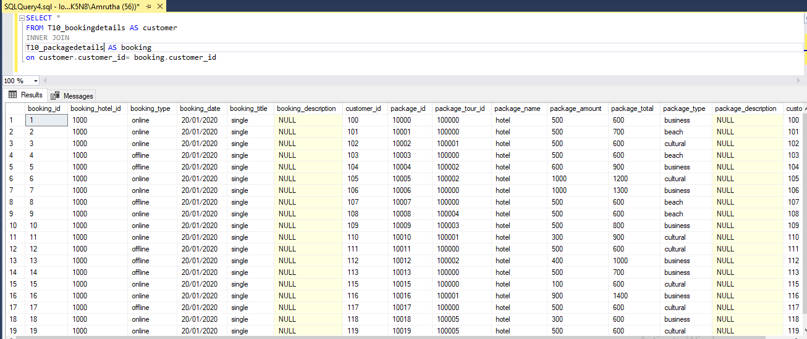

SELECT *

FROM T10_packagedetails AS customer

INNER JOIN

T10_bookingdetails AS booking

on customer.customer_id= booking.customer_id

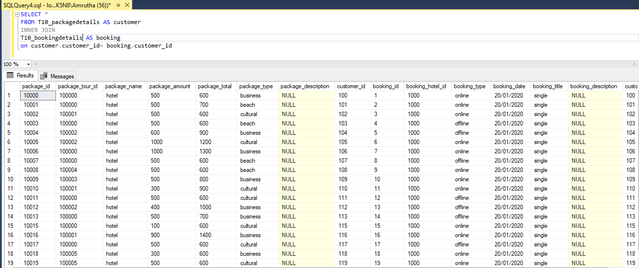

SELECT *

FROM T10_packagedetails AS customer

LEFT OUTER JOIN

T10_bookingdetails AS booking

on customer.customer_id= booking.customer_id

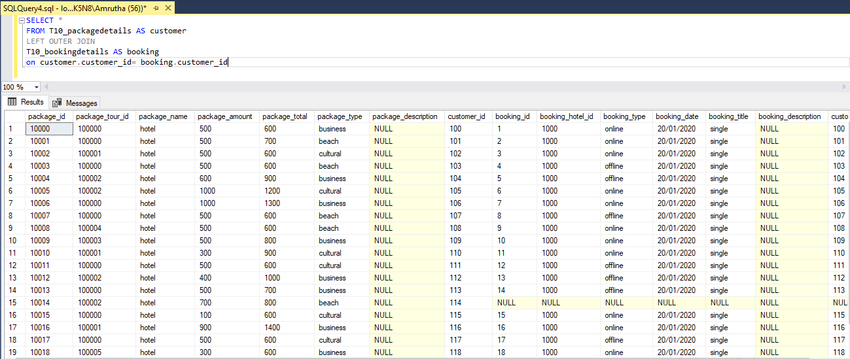

SELECT *

FROM T10_bookingdetails AS customer

LEFT OUTER JOIN

T10_packagedetails AS booking

on customer.customer_id= booking.customer_id

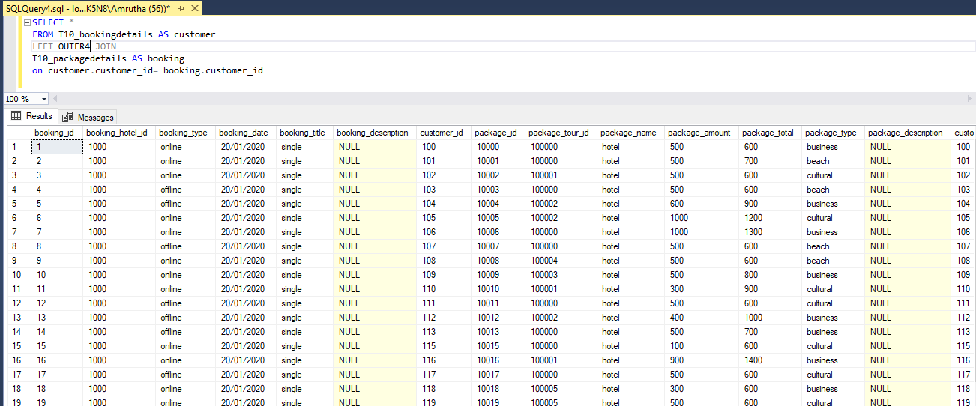

SELECT *

FROM T10_customerdetails AS customer

LEFT OUTER JOIN

T10_bookingdetails AS booking

on customer.customer_id= booking.customer_id

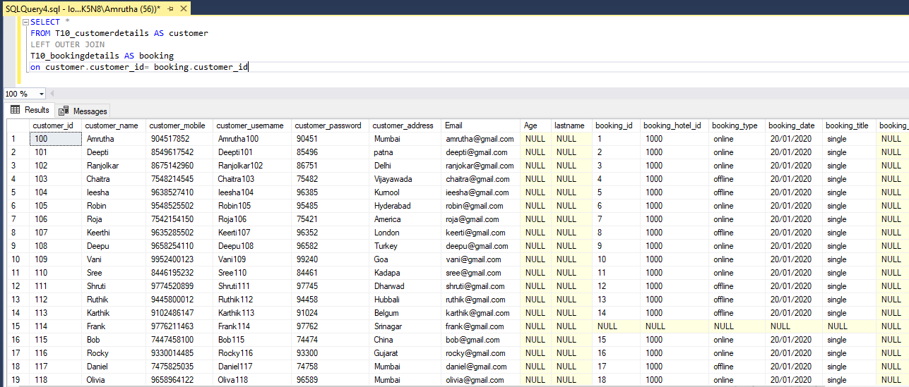

SELECT *

FROM T10_customerdetails AS customer

RIGHT OUTER JOIN

T10_bookingdetails AS booking

on customer.customer_id= booking.customer_id

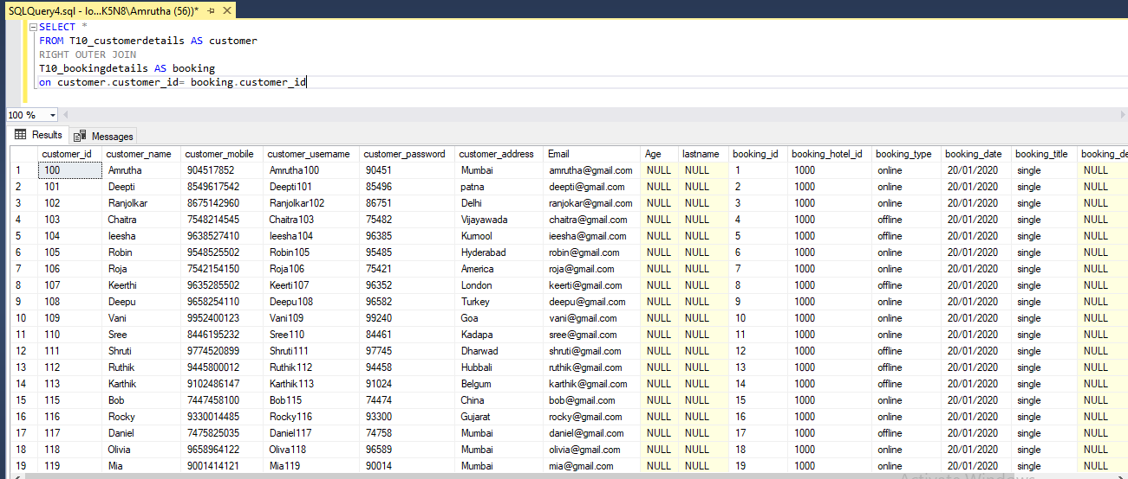

SELECT *

FROM T10_bookingdetails AS customer

RIGHT OUTER JOIN

T10_packagedetails AS booking

on customer.customer_id= booking.customer_id

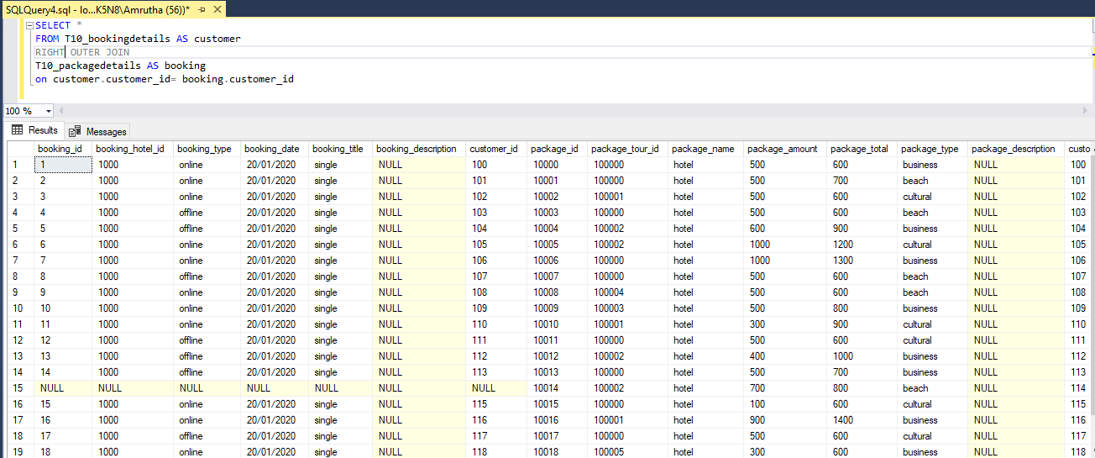

SELECT *

FROM T10_packagedetails AS customer

RIGHT OUTER JOIN

T10_bookingdetails AS booking

on customer.customer_id= booking.customer_id

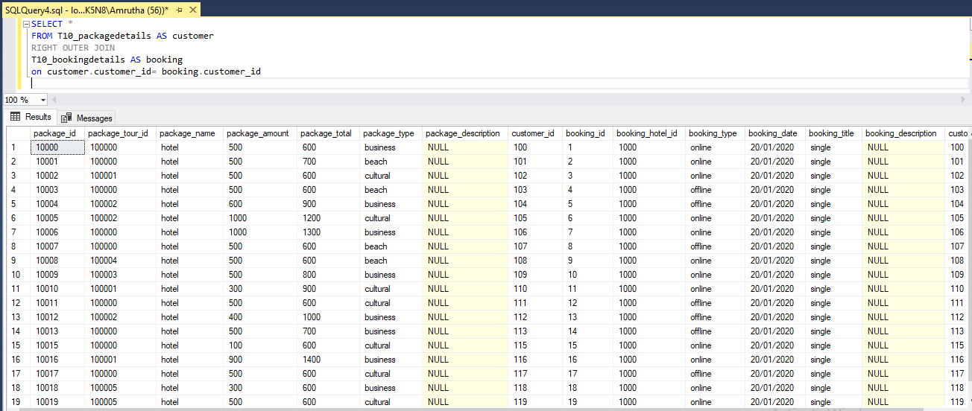

**8. Use all the above condition in JOIN as well.**

use T10_TRAVEL

SELECT package_type, SUM(package_amount) AS Amount ,MIN(package_total) AS Total_Min,AVG(package_tour_id)AS Tour_id,MAX(package_total) AS Total_Max

FROM T10_packagedetails As customer

JOIN

T10_bookingdetails AS booking

on customer.customer_id=booking.customer_id

GROUP BY package_type

HAVING package_type LIKE '__%'

ORDER BY package_type ASC;

